 |   Comune di Tolentino |  | 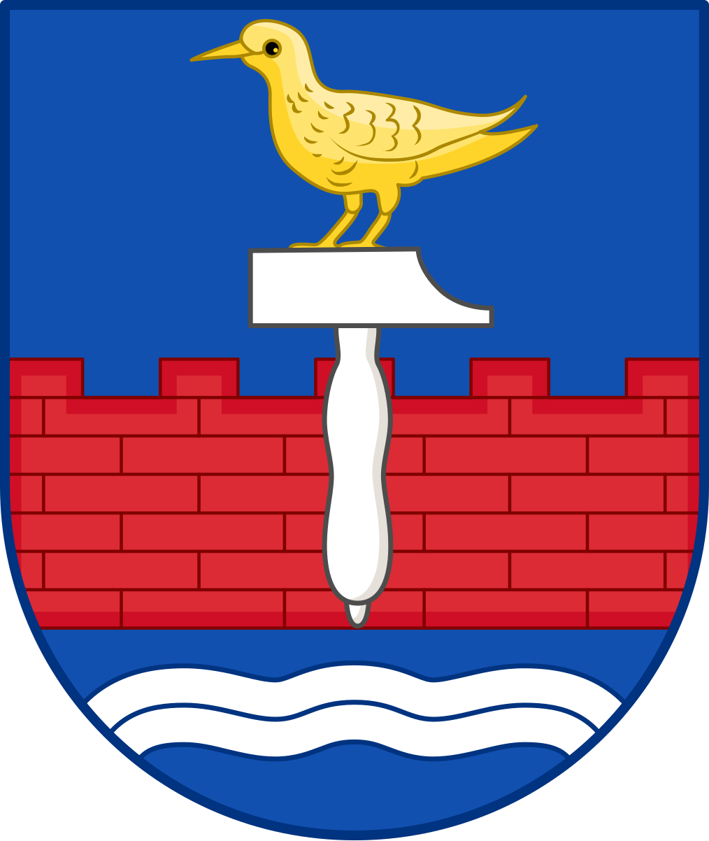  Hering Kommune

PRESS RELEASE
The European Twinning Project (ETP) is launched: the first European environmental twinning network. Tolentino as lead city.

The new European path of environmental cooperation was presented today at the Politeama Theatre in Tolentino, with the participation of institutional representatives from Italy, Norway and Denmark, including the Ambassador of Italy to Denmark.
Tolentino, December 3, 2025 – The European Twinning Project (ETP) was officially presented today, the first European initiative introducing a structured model of environmental twinning between municipalities from different countries, with the aim of promoting cooperation, sustainability, circular economy and environmental education.
The City of Tolentino has taken on the role of European lead municipality for the project, having long been committed to environmental policies and circular economy initiatives.
The project, coordinated by Nicolas Meletiou, Managing Director of ESO RECYCLING, includes as its first participating municipalities Tolentino (Italy), Alstahaug (Norway), Herning (Denmark) and Vefsn (Norway).
The official launch event was attended, both in person and remotely, by:
• Olav Fjellså, Helgeland Region, representing the municipality of Alstahaug
• Rune Krutå, Mayor of the municipality of Vefsn
• Stefania Rosini, Ambassador of Italy to Denmark
• Mauro Sclavi, Mayor of the municipality of Tolentino
• Anne Kristin Solheim, CEO Helgeland Industrier AS
• Dorte West, Mayor of the municipality of Herning
A new European model for environmental cooperation
During the presentation, the objectives and initial action lines of the ETP were outlined, defining a framework of voluntary, collaborative cooperation open to new European municipalities, aimed at fostering the exchange of experiences, the development of joint projects and coordinated participation in European programs.
The priority areas of cooperation include:
• Circular economy and resource management
Exchange of best practices, material identification and development of scalable solutions.
• Energy transition and smart communities
Renewable energy, energy efficiency, public lighting and community energy models.
• Environmental education and youth engagement
Collaboration between schools, universities, students and young professionals.
• Social inclusion and community participation
Involvement of associations, citizens and vulnerable groups in environmental initiatives.
• Green innovation and sustainable urban development
Mobility, urban regeneration, sustainable buildings, green areas and innovative local projects.
Institutional remarks
During the event, institutional representatives from the participating countries emphasized the importance of a concrete European dialogue focused on the implementation of shared environmental initiatives.
The session was opened remotely from Copenhagen by Stefania Rosini, Ambassador of Italy to Denmark, who highlighted the value of circular economy projects linking Italy and Denmark and expressed her best wishes for the success of the initiative at the European level, with a special greeting to the Mayor of Herning, Dorte West, and all the mayors present.
The speeches took place in the presence of the press, citizens of Tolentino and local representatives, including Fabio Sturani, Head of Relations with Italian Municipalities at ESO RECYCLING; Marco Ciarulli, President of Legambiente Marche; and Paolo Gattafoni, President of Cosmari Srl.
“We are very pleased,” said Mauro Sclavi, Mayor of Tolentino, “to be the lead municipality of this important project, which excellently reflects the founding principles of Europe. We are launching a network and a strategy where multiple entities, at different levels, work together constructively with the aim of protecting the environment and giving a second life to waste that can be recovered, recycled and transformed into primary/secondary raw materials, giving a real future to our planet. Thanks to ESO RECYCLING for proposing and implementing this initiative and to all the partners who have joined. We will do our part.”
“This project is based on a simple idea: bringing European communities together through concrete environmental solutions,” said Nicolas Meletiou, Managing Director of ESO RECYCLING. “For over twenty-five years, we have been transforming end-of-life materials from the sports, fashion and work sectors into new resources for the community, and today this experience becomes part of a shared European path. The ‘Amato Cannara’ plant in Tolentino is one of the reference points of a network we are building together with partner municipalities. With our presence in Herning, Denmark, since October 1, 2025, we are expanding this model beyond Italian borders to create an international system capable of collecting, enhancing and reintroducing waste materials into a truly circular cycle. The ETP represents the first step of a new European architecture, open and ready to grow.”
ESO RECYCLING Società Benefit arl
ESO RECYCLING is an Italian company specialized in the recovery and transformation of end-of-life materials from the sports, fashion and personal protective equipment (PPE) sectors. Based in Tolentino (Marche), at the Amato Cannara facility, the company converts waste materials, both post-consumer and pre-consumer, into high-value secondary raw materials for sustainable applications.
These include circular projects such as Betty’s Garden® and The Filippide Track®, which reuse recycled materials to create new sports and playground spaces. By prioritizing traceability, compliance and environmental responsibility, ESO RECYCLING enables institutions and companies to adopt truly circular solutions, reducing waste and minimizing landfill impact.
In the photo from left:
Nicolas Meletiou, Managing Director of ESO RECYCLING
Olav Fjellså, Helgeland Region, representing the municipality of Alstahaug
Mauro Sclavi, Mayor of Tolentino
Anne Kristin Solheim, CEO Helgeland Industrier AS
Press Office:
Coordination: ESO RECYCLING – Nunzia Vallozzi
ufficiostampa@eso.it – +39 371 467 7349

